**Set up document**

This is a detailed document which provides information about the agreements made with the client, the most important situations all users will go through, an evaluation of the deliverables’ importance and the design of all our deliverables.

**Contents**

1. Changes added to this setup document 2

2. Agreements made with the client 2

3. Processes 3

3.1 Buying a Ticket and Reserving a Camping Spot 3

3.2 Selling Food and Drink 3

3.3 Selling Souvenirs 4

3.4 Assigning Items for Loaning 5

3.5 Returning Loaned Items 6

3.6 Signing Visitors in the Event Area 6

3.7 Visitor Entering the Event 7

3.8 Visitor Leaving the Event Grounds 7

3.9 Returning to the Event 8

3.10 Entering the Camping Area 8

3.11 Exiting the Camping Area 8

3.12 U Using Dashboard 9

4. Functional Requirements 9

4.1 MoSCoW 9

5. Applications GUI 10

5.1 Check in application 11

5.2 Check out application 12

5.3 Entrance application 12

5.4 Exit application 12

5.5 Loan shop application 13

5.6 Food shop application 15

5.7 Souvenir shop application 16

5.8 Camping entrance application 17

5.9 Camping exit application 17

5.10 ATM application 17

5.11 Login application 18

6.Website Wireframe 18

6.1 BUY TICKETS Page 18

6.2 VENUE Page 20

6.3 TERMS & CONDITION Page 21

6.4 Login Page 21

7. Erd 22

1. **Changes added to this version of the setup document**
   1. Added *3.9 Returning to the event*
   2. Added *3.11 Exiting the camping spot*
   3. Added *5.1 Check in application*
   4. Added *5.2 Check out application*
   5. Added *5.8 Camping entrance application*
   6. Added *5.9 Camping exit application*
   7. Added *5.11 Login application*
   8. Added *5.10 ATM application*
   9. Updated*: All applications design and description*
2. **Agreements made with the client**
   1. For the event we should aim at collecting as little data as possible from the visitors
   2. All tickets have the same price and a single ticket
   3. The only condition on which the visitors can attend the event is if they are above 18 years old.
   4. The ticket is non refundable
   5. The maximum number of visitors is 1000
   6. Visitors can add money on their event account through  the ATM machines at the event area.
   7. The event’s duration is from 14-06-2019 at 15:00 until 16-06-2019 at 22:00. The website should be functioning a week earlier.
   8. Applications should be three types – for the visitors, for the employees at the events and for the client.

**3. Processes**

In this set up document we describe all meaningful interaction between the system and the user. The users are the client, employees and the event participants.

**3.1 Use Case: Buying a Ticket and Reserving a Camping Spot**

**: Visitor**

**Main scenario:**

1. The visitor opens the event website
2. The visitor buys a ticket from the website
3. The visitor sign up on the page
4. The visitor login on the page
5. The visitor confirms the payment
6. The system answers in sending an email with the visitor ID to the visitor

**Extensions:**

3a. The visitor buys more than 1 ticket:

The system asks the details of each person and it uses for administration and event account ( the detail asks first name, last name and email)

4a. The visitor reserves a group camping spot at the event

* The employee asks id or passport each person in the group if they reserved a camping spot the employee record (First name, Last name, Email)

4b. The visitor does not reserve a camping spot.

* Don’t participate the event

**3.2 Selling Food and Drink**

**Performer:** Employee, Visitor

**Main scenario**:

1. The visitor scans their bracelet
2. The employee hosts the product to the visitor
3. The visitor approves the order
4. The system deduct an amount from the visitor account and print a receipt

**Extensions:**

3a. The visitor decays the whole order

* Doesn’t dedicate an amount from the account

3b. The visitor requests to cancel some of the orders

The employee update the order

3c. The visitor account doesn’t have enough money

* The visitor informed their account status by the system
* The system cancel the visitor order
* The visitor add money to their event account through ATM Machine
* The visitor reorder the iteams and confirm the order
* The system deduct an amount from the visitor account and print a receipt

**3.3 Selling Souvenirs**

**Performer:** Employee, Visitor

**Main scenario:**

1. The visitor scans their bracelet
2. The employee host products to the visitor’s
3. The visitor aprove the order
4. The system deduct an amount from the visitor account and print a receipt

**Extensions:**

3a. The visitor decays the whole order

* Doesn’t deducte an amount from the visitor account

3b. The visitor requests to cancel some of the orders

* The employee update the new order

3c. The visitor account doesn’t have enough money

* The visitor informed their account status by the system
* The system cancel the visitor order
* The visitor add money to their event account through ATM Machine
* The visitor reorder the iteams and confirm the order
* The system deduct an amount from the visitor account and print a receipt

**3.4 Get items by loan**

**Performer:** Employee, Visitor

**Main scenario:**

1. The visitor scans their bracelet
2. The employee host the iteams for the visitor
3. The visitor confirms the loan
4. The system deduct an amount from the visitor account and print a receipt

Extensions:

3a. The visitor decays the whole order

* Doesn’t deducte an amount from the visitor account

3b. The visitor requests to cancel some of the orders

* The employee update the new order

3c. The visitor account doesn’t have enough money

* The visitor informed their account status by the system
* The system cancel the visitor order
* The visitor add money to their event account through ATM Machine
* The visitor reorder the iteams and confirm the order
* The system deduct an amount from the visitor account and print a receipt

**Performer:** Employee, Visitor

**Main scenario:**

1. The visitor scans their bracelet
2. The employee scans products, removing them from the visitor’s account

Extensions:

2a. The visitor decides to cancel the whole returning

* The employee clicks on the “Reset session” button

2b. The visitor wants to cancel the returning of a specific item

* The employee clicks on the “Reset session” button

**3.6 Signing Visitors in the Event Area**

**Actors:** Employee, Visitor

**Main scenario:**

1. The employee checks the ID of the visitor to ensure they are above 18 years old
2. The visitor provides their visitor ID (barcode)
3. The employee scans the visitor ID and the visitor’s credentials appear on the screen
4. The employee scans a bracelet linking it to the visitor’s account

**Extensions:**

1a. The visitor is below 18 years old

* The visitor is not let inside the event grounds

2a. The visitor does not have an account

* The visitor is asked to create an account (a device with the website is provided on the spot for people with no phones)

3a. The employee scans the barcode, but the visitor does not have an event account (provides a fake barcode)

* An error is displayed, and the visitor is asked to either create an event account or leave; The visitor’s credentials do not appear on the screen

**3.7 Visitor Entering the Event**

**Actors**: Visitor

**Main scenario:**

1. The visitor scans their bracelet on the gate scanner
2. The gate to the event opens and lets the visitor in

**Extensions:**

1a. The visitor uses an entrance gate, but the gate does not open

* A message “Please, scan again!” appears on the display

**3.8 Use Case: Visitor Leaving the Event Grounds**

**Actors**: Employee, Visitor

Main scenario:

1. The visitor scans their bracelet in order to open the “Temporary exit” gates
2. The gates open to let the visitor out

**Extensions**:

1a. The visitor scans their bracelet in order to open the “Permanent exit” gates:

* The gates open to let the visitor out
  + - * An employee asks for the visitor’s bracelet in order to remove the visitor’s ID from it

1b. The visitor uses the “Permanent exit” without returning the loaned items

* + - * The scan screen displays a message that the visitor has loaned items

1c. The visitor is not allowed to leave until they return their loaned items 1c. The visitor uses any of the exits and the door does not open

* + - * A message “Please, scan again!” appears on the display

**3.9 Returning to the Event**

**Actors:** Employee, Visitor

**Main scenario:**

1. The visitor comes back and scans their bracelet to open the “Temporary exit” gates
2. The gates open to let the visitor back in the event

**Extensions:**

1a. Ask a guard for a manual check and back to the event

**3.10 Entering the Camping Area**

**Actors:** Visitor, Employee

**Main scenario:**

1. The visitor scans their bracelet on the door scanner of the camping area
2. The door opens and lets the visitor in

**Extensions:**

1b. The visitor scans their bracelet more than once:

* The door does not open. A message describing the problem and asking for speaking with an employee appears on the screen.
* An employee opens the door for the visitor.

**3.11 Exiting the Camping Area**

**Actors:** Visitor, Employee

**Main scenario:**

1. The visitor scans their bracelet on the door scanner of the camping area
2. The door opens and lets the visitor out

**Extensions:**

1b. The visitor scans their bracelet more than once:

* The door does not open. A message describing the problem and asking for speaking with an employee appears on the screen.
* An employee opens the door for the visitor.

**3.12 Use Case: Using Dashboard**

**Actors**: Client

**Main scenario:**

1. Without the need to register, the client logs into the website using their email and password
2. The DASHBOARD page automatically loads

**Extensions:**

1b. The client cannot enter their account

* + The client can contact the developer team and ask for help

1. **Functional Requirements**

In this section, the website and the applications will be prioritized (using MoSCoW) based on the importance of their functions.

**4.1 MoSCoW**

MoSCoW is a prioritization method. It stands for Must have, Should have, Could have and Won’t have.

Here is a description of the categories:

Must have

Requirements labeled as Must have are crucial for delivering before the current deadline.

Should have

Requirements labeled as Should have are important to deliver before the current deadline but are not a big thread for the whole project.

Could have

Requirements labeled as Could have are not of great importance for the current deadline.

Won't have (this time)

These are requirements which the project team has agreed will not be delivered as part of this timeframe.

Since the MoSCoW method uses timeslots, for the current timeslot (block one of the second semester) the requirements could be graded as follows:

|  |  |
| --- | --- |
| Must have | Properly working applications |
| A fully functioning website |
| A public database, communicating with both the applications and the website |
| Should have |  |
| Could have |  |
| Won’t have (this time) |  |

**5. Applications GUI**

This section will provide images and description of the applications.

**5.1 Check in application**

This application will be used at the entrance of the event. The employees at the entrance will scan the barcodes (visitors’ ID) to link them to the bracelets. This will display the visitor’s name on the screen if the visitor is on the database. If not, an appropriate message will be shown.

**5.2 Check out application**

When the visitor checks out, the employee will first scan their bracelet on the gates’ scanners (to open the gates) and then scan the bracelet to remove the visitor’s number from them.

**5.3 Entrance application**

This application will be used at the front gates of the event and will allow people with bracelets to enter. It will prevent people from cheating their way into the event by registering the scanned bracelets as “Inside the event” and this will block them for further scanning on this side of the gate.

**5.4 Exit application**

This application will allow a visitor with no loaned items to leave the event. The gates of the event open when the bracelet is scanned, and the visitor does not have any loaned items on their event account. The application again prevents from cheating.

MPK Rocks Setup Document

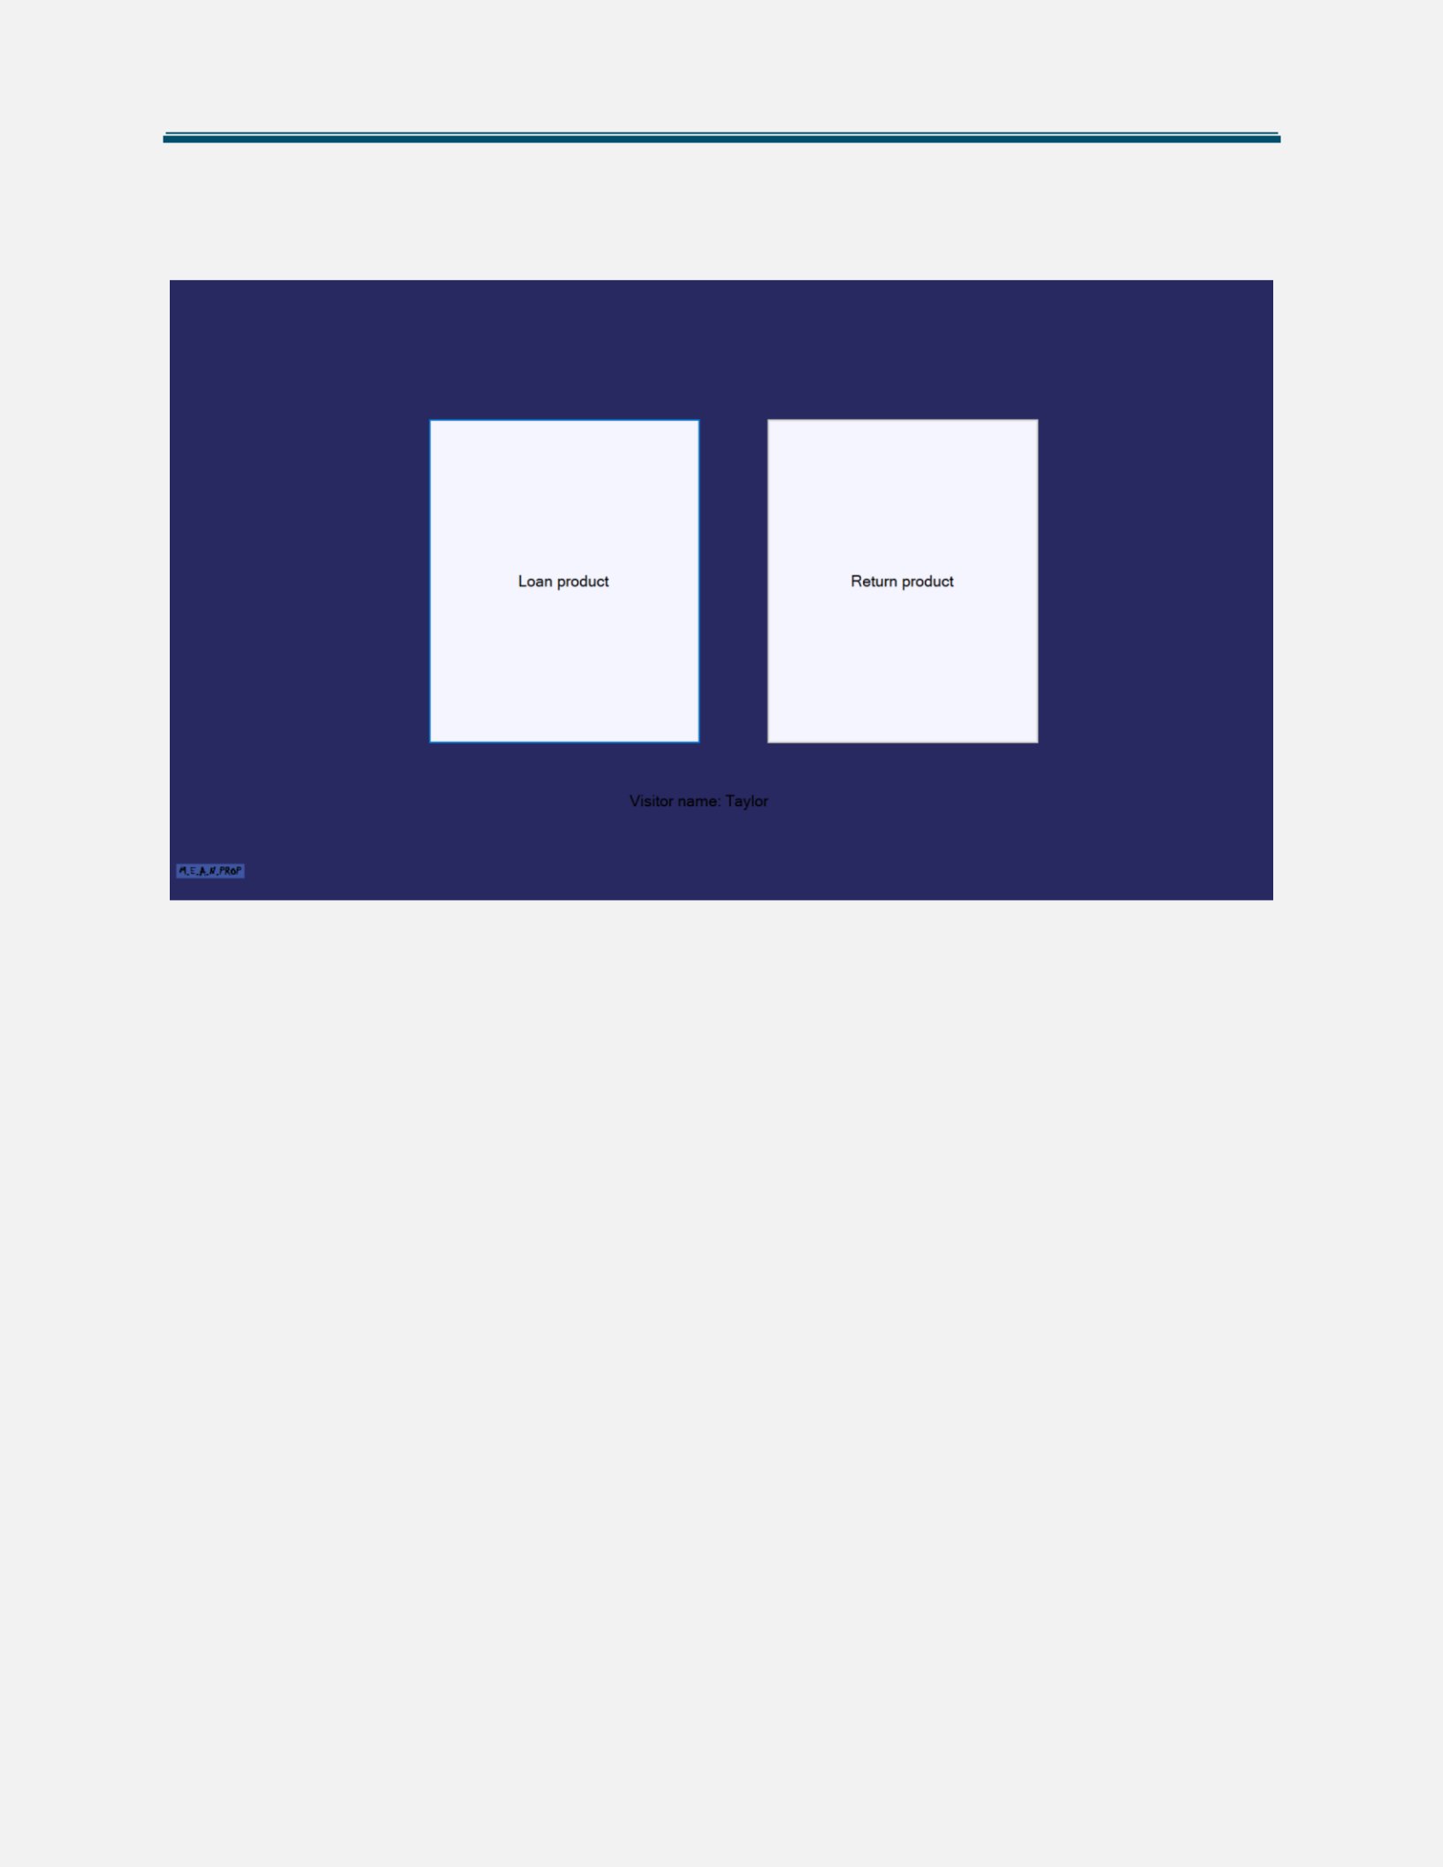

The loan shops will use this application. The main screen will have no buttons, it will only ask for the visitor to scan their bracelet. When they scan it for the first time, the screen below appears. If they have some loaned items on their account, the screen above appears.

MPK Rocks Setup Document

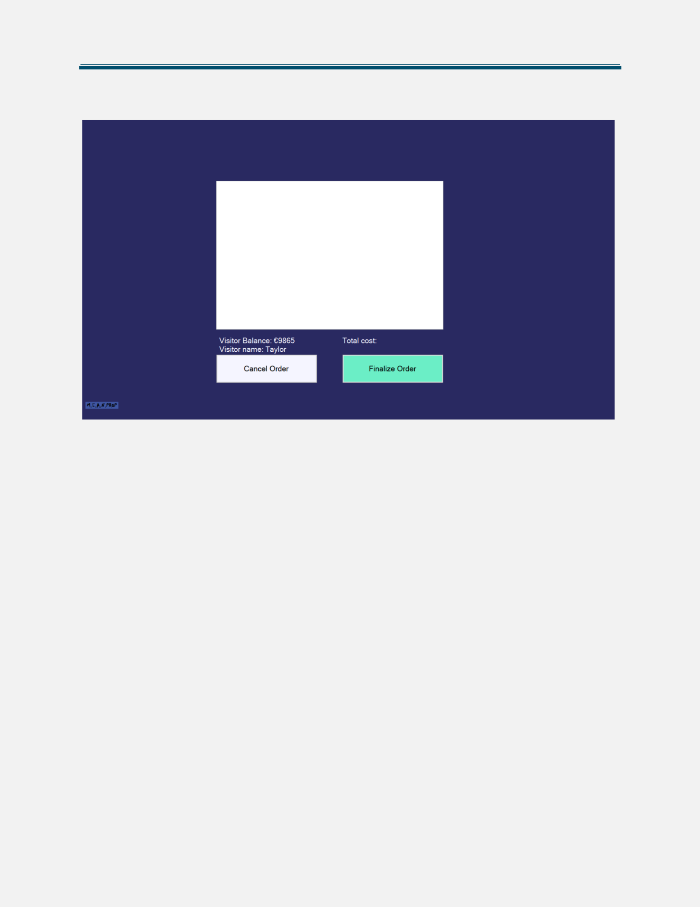

The “Loan product” button leads to the “Loan screen” and the “Return product” button to the “Return screen”.

The “Loan screen” will display a list box with the scanned items for this order of the visitor. The application also shows the total cost of all items added to the order. Scanning an item for the second time will remove it from the current order. The “Cancel order” button clears the whole list and the “Finalize order” button deducts the items’ cost from the account.

MPK Rocks Setup Document

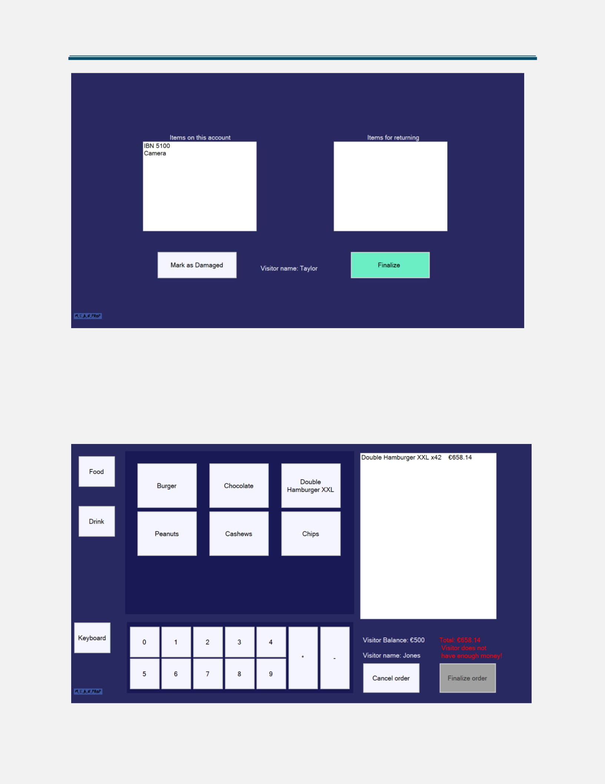

The “Return screen” is used to return loaned items. The employee sees a list of the items that the visitor has loaned on the left. On the right there is a list of items for returning. After scanning an item, it disappears from the left list and appears on the right. The button “Mark as damaged” removes an item from the list, marks it as damaged and also makes it impossible for further loaning. The button “Finalize” will permanently return the items in the right listbox.

MPK Rocks Setup Document

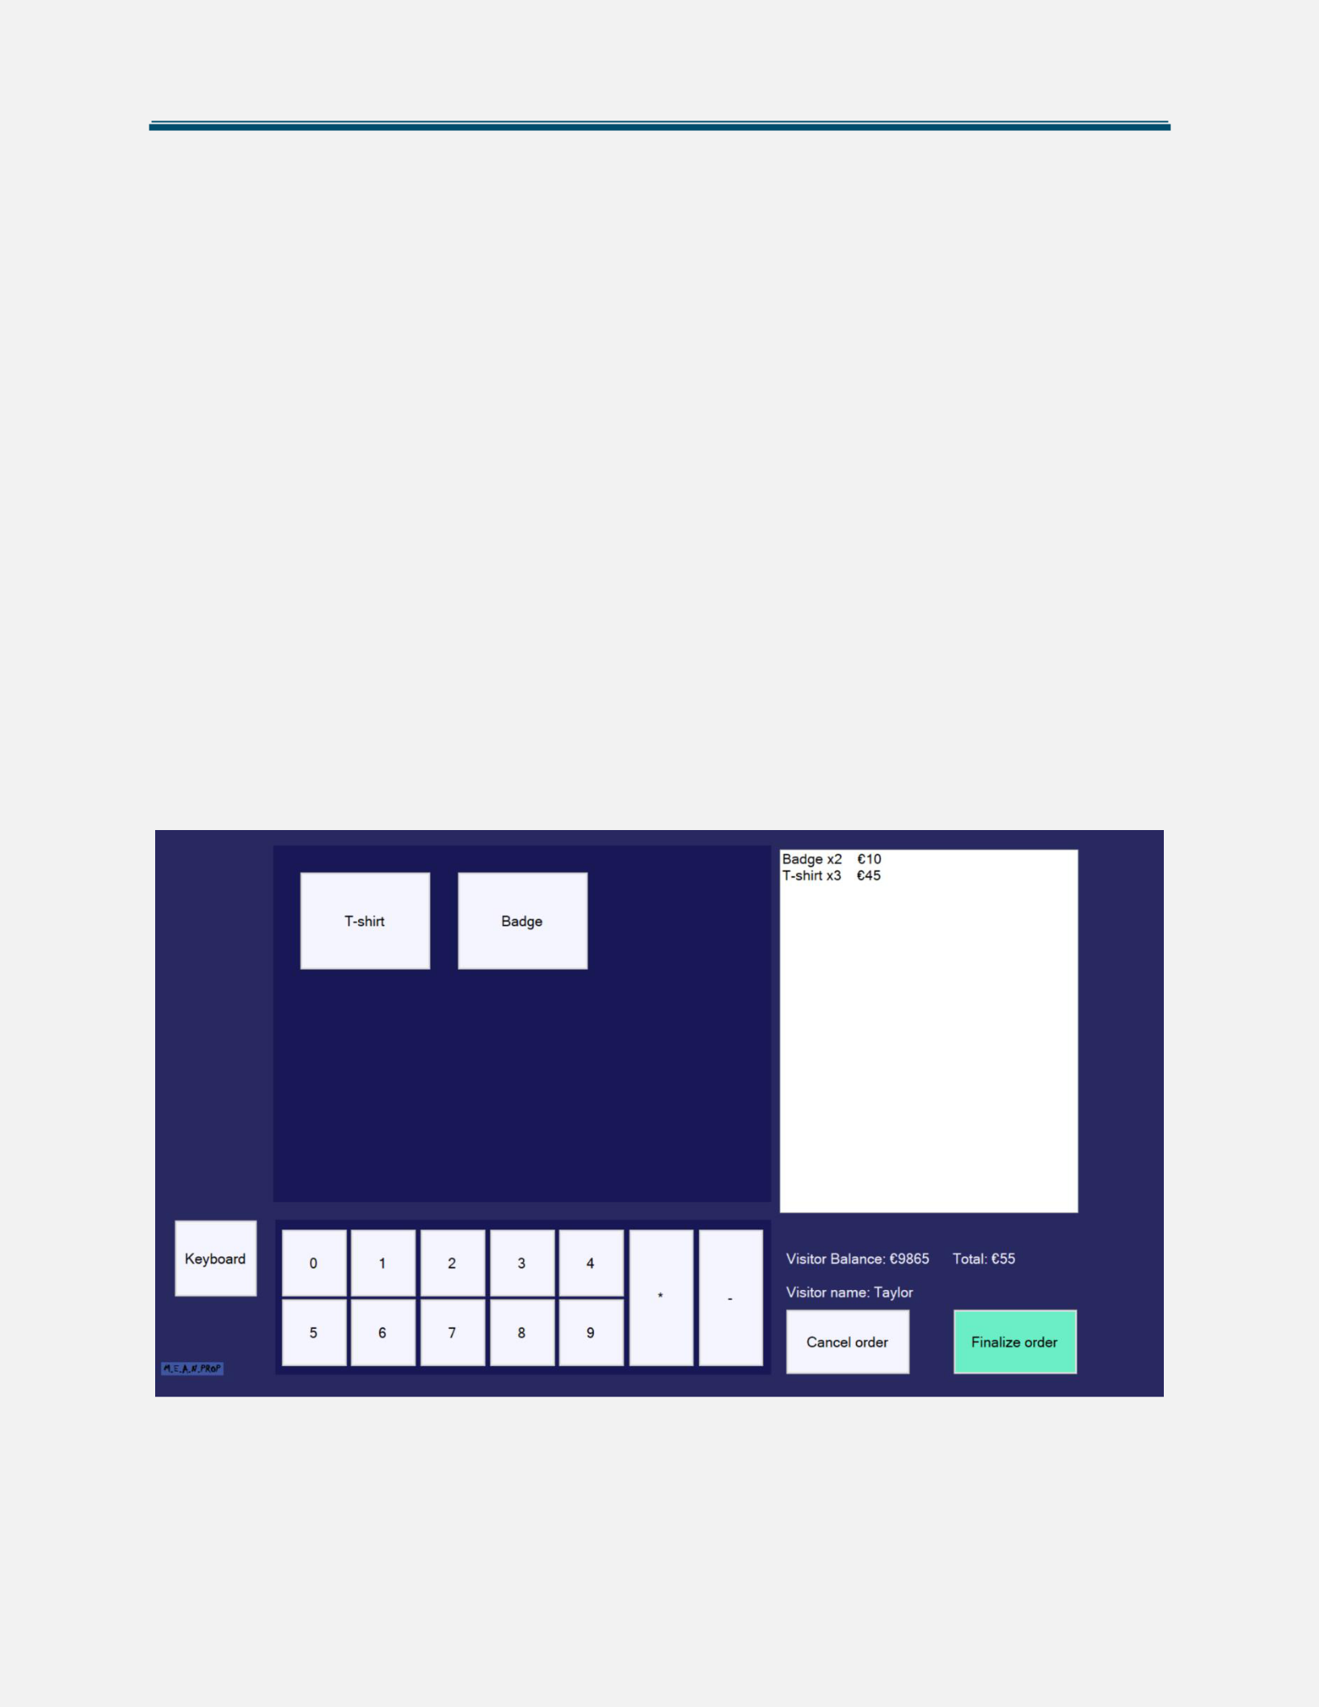

**5.6 Food shop application**

The main screen of the application shows a message to the visitor to scan their bracelet after which the screen above appears.

On the top left of the shop application there are two buttons – “Food” and ”Drink”. Clicking on the “Food” button displays all the food available in the shop in the middle of the screen. Clicking on the “Drink” button displays all the drinks available in the shop. On the right there is a list that shows all the products that the visitor adds to their order. The application also show the total cost of all items added to the order and the visitor’s balance.

The button “Keyboard” displays (or hides) a keypad with the numbers, a button “-” and a button “*”. Clicking on the “*”, a number and scanning an item (or selecting it from the menu) will result on adding it that many times. Similarly, clicking on the “-”, a number and scanning an item (or selecting it from the menu) will result on removing it that many times.

The “Cancel order” button clears the whole list (also shows the main screen again) and the “Finalize order” button deducts the cost of the items from the account (also shows the main screen again).

**5.7 Souvenir shop application**

The main screen of the application asks the visitor to scan their bracelet after which the screen above appears. The employee scans the wanted item and it appears on the list.

The keyboard works the same way as in the food shop application.

Clicking on the button “Finalize order” results in deducting the cost of all items from the visitor’s account and shows the main screen again. Clicking the button “Cancel order” clears the list of all items and shows the main screen.

**5.8 Camping entrance application**

This application does not have a GUI. Its functionality is to allow visitors to scan their bracelet and open the door of the camping area. Also prevents from cheating.

**5.9 Camping exit application**

This application does not have a GUI. Its functionality is to allow visitors to scan their bracelet and open the door of the camping area. Also prevents from cheating.

**5.10 ATM application**

This application does not have a GUI. Its functionality is to translate ATM log files and update the database. It runs as a process in the background and waits for log files to be sent to a specific folder.

MPK Rocks Setup Document

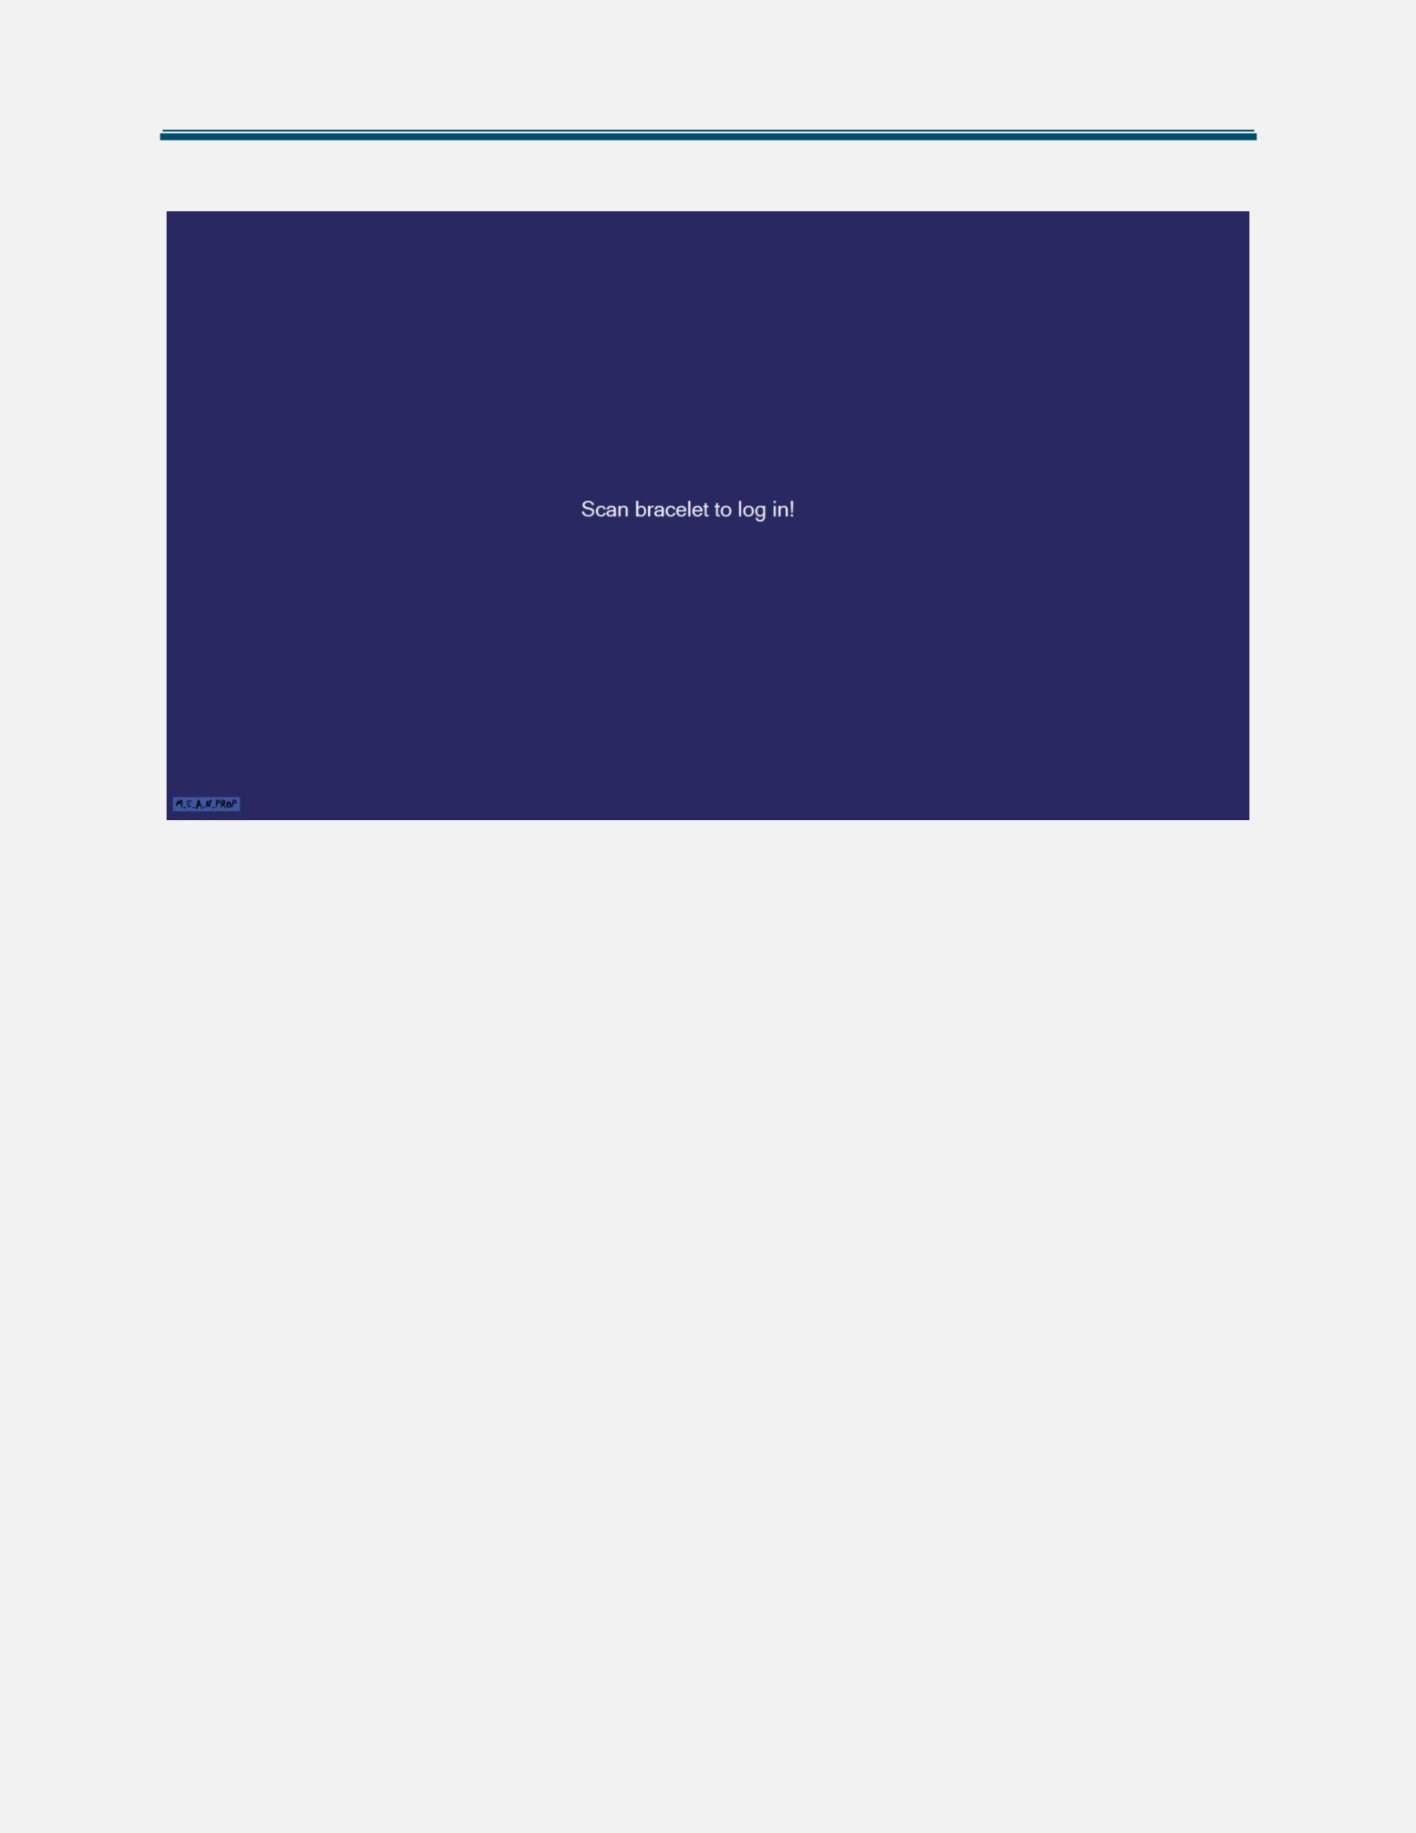

**5.11 Login application**

The Login application starts before some of the applications (Cashier, Loan stand, Souvenir). An employee should scan their bracelet in order to login. If somehow a visitor scans their bracelet instead, an appropriate message appears.

**6.Website Wireframe**

This section will contain the website’s wireframes and description of each page.

**6.1 BUY TICKETS Page**

MPK Rocks Setup Document

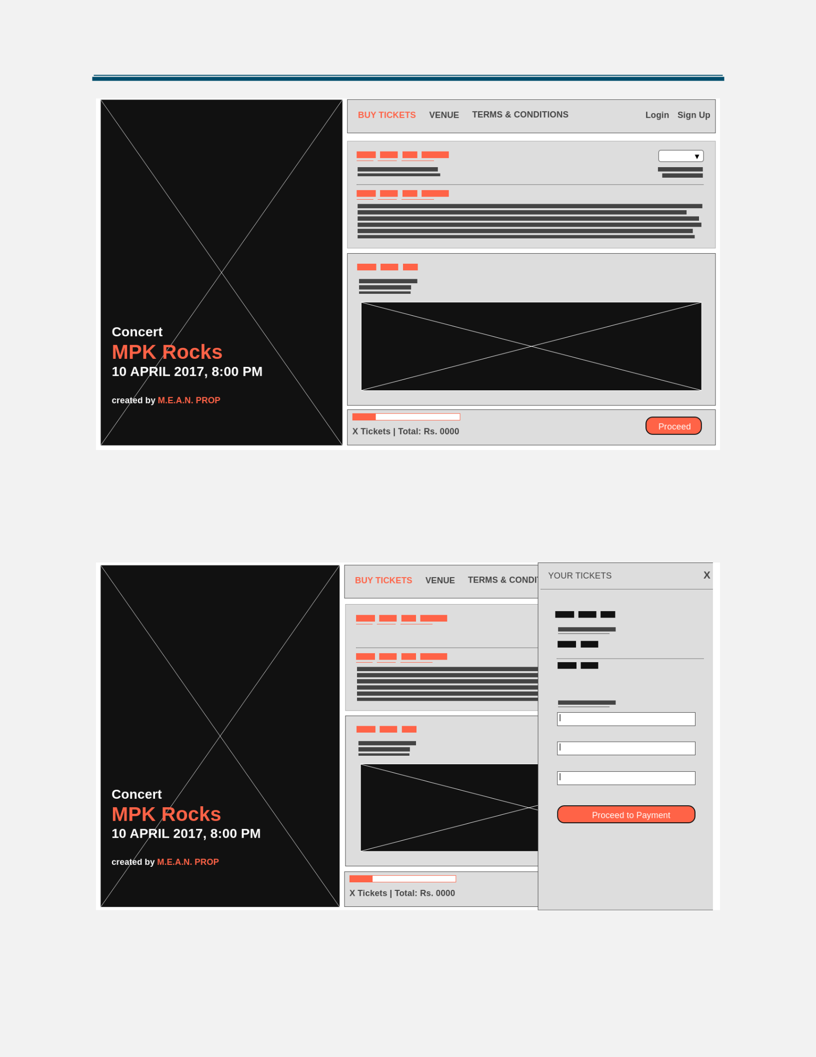

The “Buy tickets” page allows the visitors of the event to buy tickets and reserve camping spots. This results in creating an event account. Buying more than one ticket and reserving a spot for more than one person is possible through dropdown menus. After selecting number of tickets and camping spots, extra fields for credentials appear.

MPK Rocks Setup Document

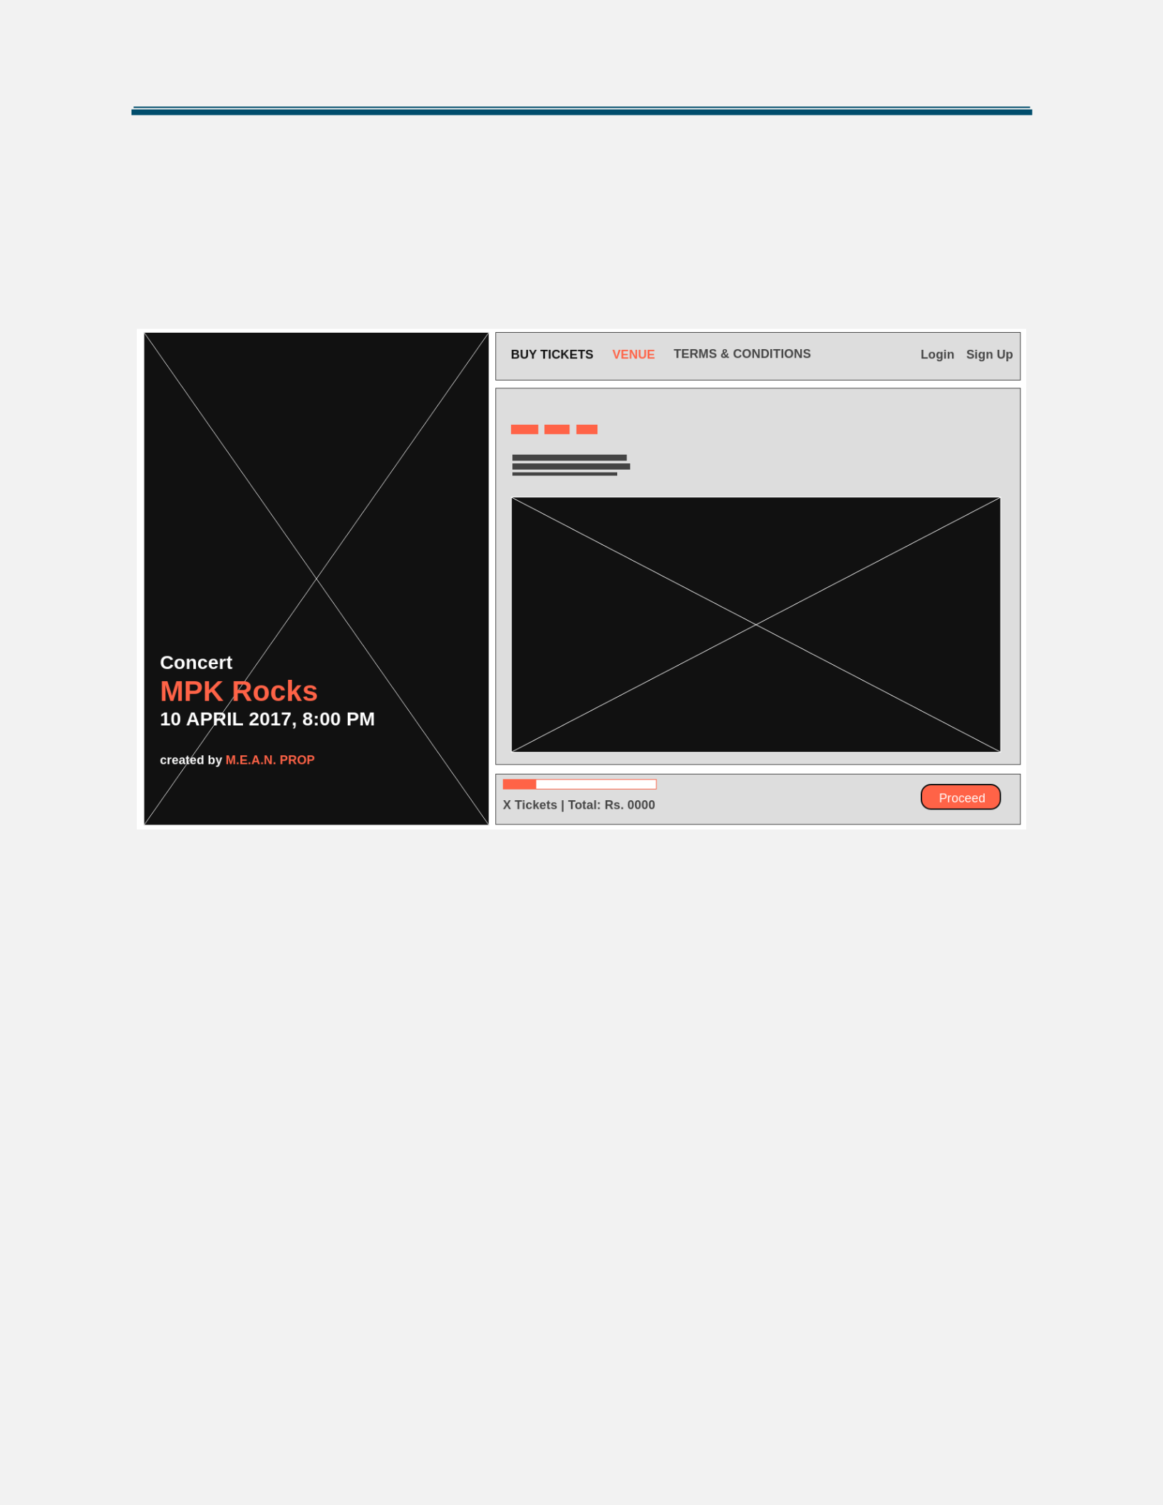

Clicking on a button “Proceed” opens a side menu which shows the number of tickets that the visitor has added to their cart, as well as the total amount the visitor must pay (plus the camping spot). The visitor should type their bank account in order to pay for their purchase.

**6.2 VENUE Page**

The “Venue” page contains a Google Maps window where the visitor can see the address of the event.

MPK Rocks Setup Document

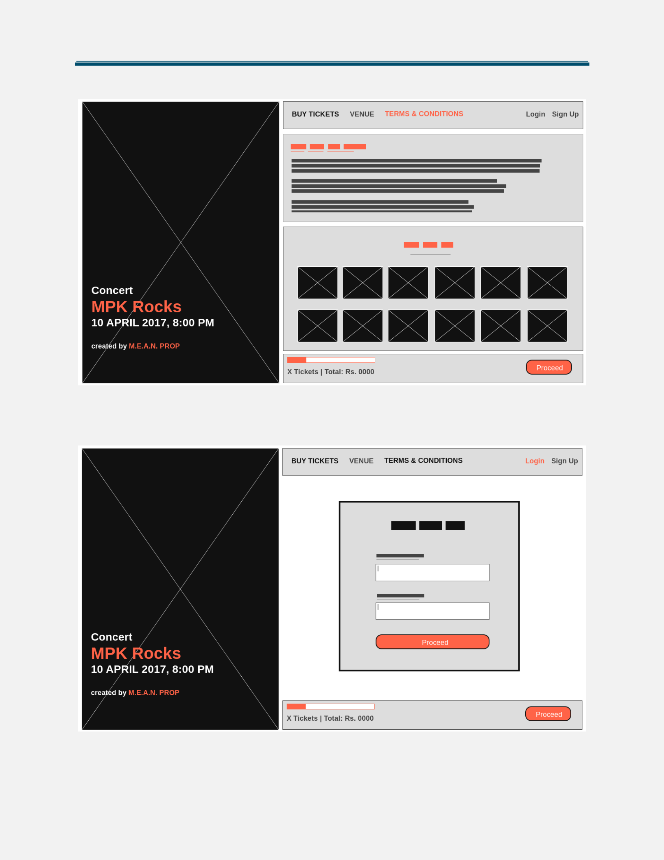

**6.3 TERMS & CONDITION Page**

The “Terms and Conditions” page describes the rules on which a user must create their account.

**6.4 Login Page**

The “Login” page asks for the visitor’s credentials and allows for the visitor to enter their account and check for their balance for example.

MPK Rocks Setup Document

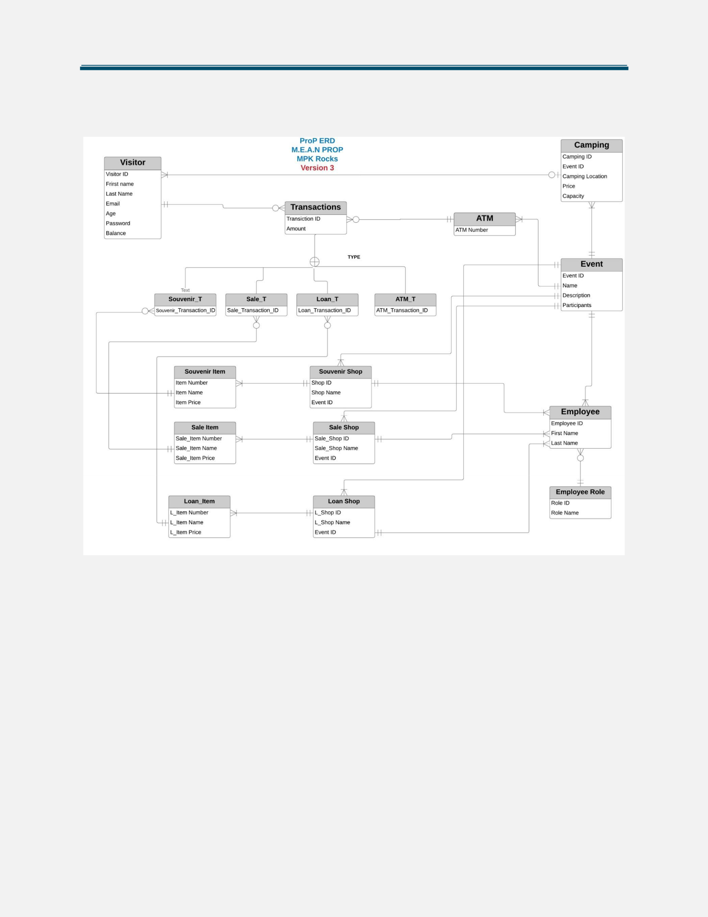

**7.ERD**

In this section of the document an ERD and a brief justification regarding the design will be included.

The ERD’s two main entities are the Event and Visitor. We are using an Event entity so that the ERD can be used in other events too. The Visitor entity is connected with the Transactions entity which has four subtypes for each type of transaction that the visitor can make (in the souvenir shops, the food and drink shops, the loan shops and the ATM machines).

Since we will want to print out receipts from all shops and the ATM, we have included the transaction ID in the Transactions entity, the name of the shops in all shops, the price for each selling or loaning item in the Sale item and the Loan item entities and the employee’s ID in the Employee entity.

The Visitor entity is directly connected to the Camping entity and a visitor can either rent one or not. A camping spot can be rented by zero or more people.